**Experiment No: 11 Date:**

**Title:** Installation of CMS and designing web pages using CMS.

**Objective:** To provide students in-depth theoretical concept of XML technologies.

**Theory:**

The first step is **download  XAMPP**from this link: <https://www.apachefriends.org/es/index.html>. You must download it **for Windows**. XAMPP is a kind of server on your computer.

**Click with the right button on the file** you have downloaded and choose the option **“Execute as administrator”**.

You will see a welcome window. **Click on *Next*.**

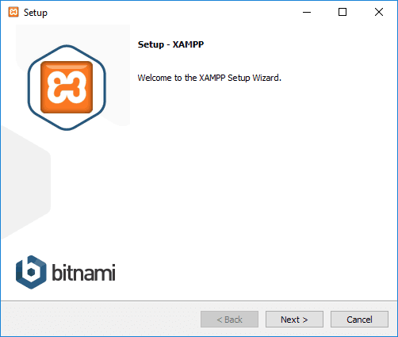

On the next screen, **choose: Apache, MySQL, PHP and phpMyAdmin**. After click on *Next*.

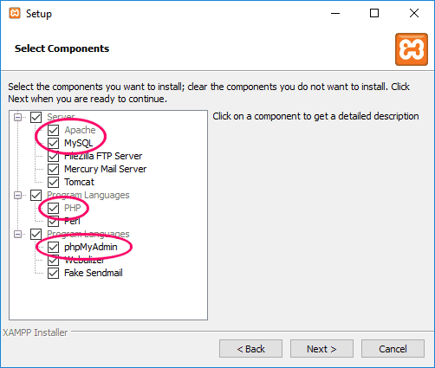

On the next screen you have to **choose the folder where you want to install XAMPP**. The default folder is: *C:\xampp*.

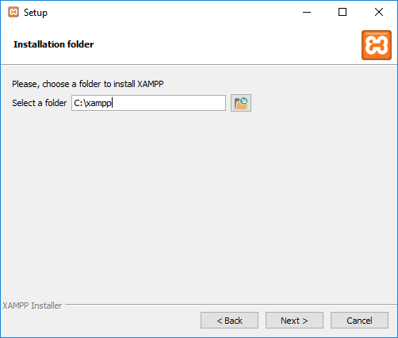

On the next screen it simply shows you if you want more information about the modules of Bitnami you can install on XAMPP. **Do not choose this option**.

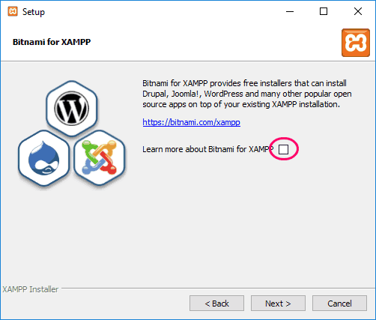

On the last screen, simple **click on *Next* to execute the installation**.

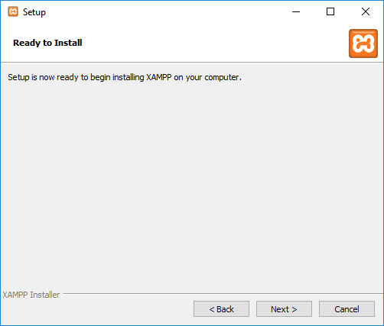

You will see another window with the progress of the installation. **When it has finished, click on *Next***.

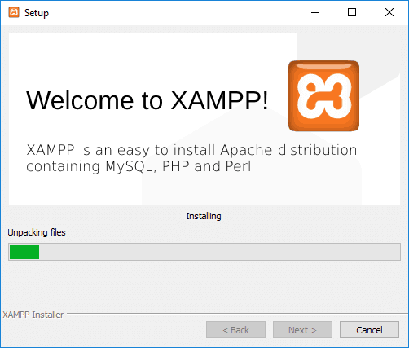

Finally, you will see a window reporting **the installation is complete**. There is an option to open the control panel of XAMPP already. **Click on *Finish***.

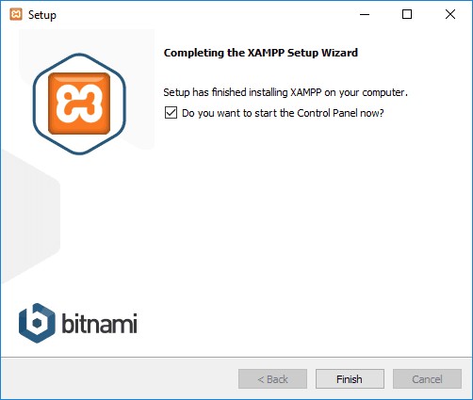

When you first open the control panel of XAMPP you will see an option to **choose the language** (English or German). Choose the one you want and click on *Save*. Now you will see the control panel with all the installed elements.

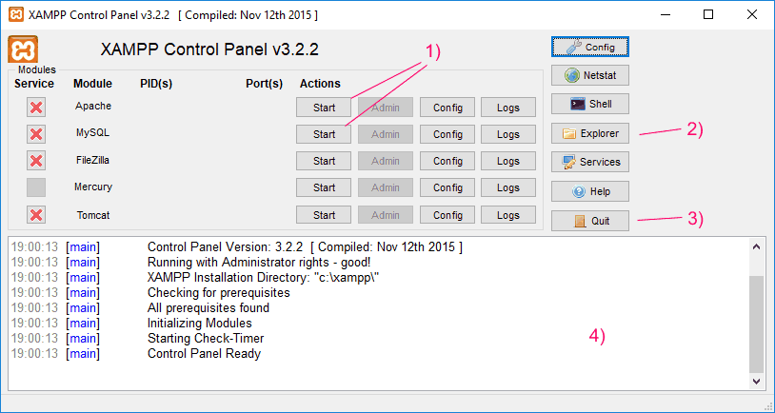

Click on **Start for Apache and MySQL (1)**. It will run the Apache server and the data base gestor. When they are running the will be **green**.

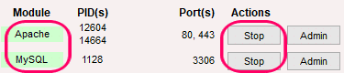

You will be able to stop them clicking on Stop. With the button *Explorer* (2) you can go to the folder where you have installed XAMPP. The Quit button (3) is to close XAMPP. On the lower panel (4) you will see all the messages about the local server. Remember, always you want to use WordPress on local, you must start Apache and MySQL.

Before install WordPress, you need to **create a date base**. We will use *phpMyAdmin*. From XAMPP panel click on *Admin* button of MySQL.

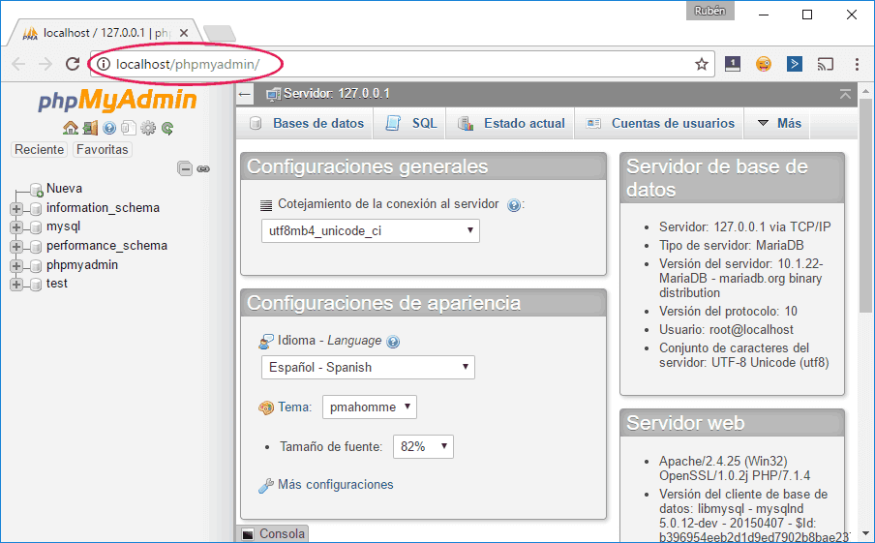

On phpMyAdmin you will see the created data bases on the left side. On this side, click on *Nueva.*

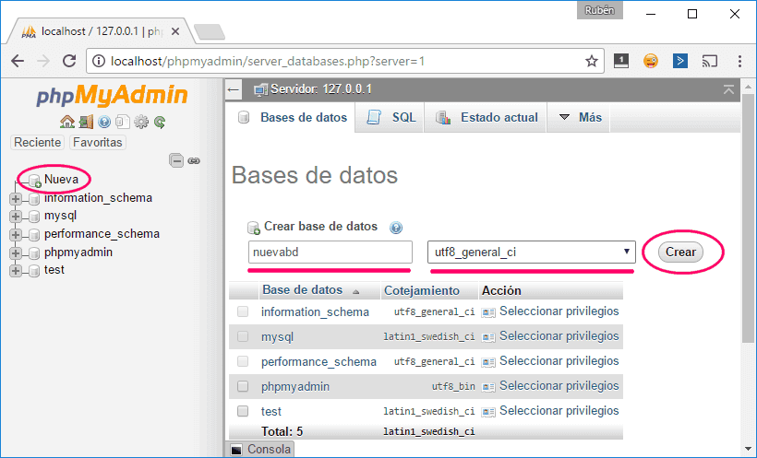

On the right side choose the data base name and as *Cotejamiento* choose the option **utf8_general_ci**. Click on *Crear*.

After, on the left side you will have a new data base.

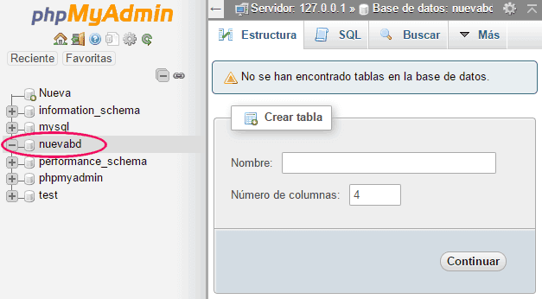

Remember, **your user of the data base is *root***; you will need it later when you install WordPress.

**Pre-installation of WordPress**

There are two kind of wordpress, **wordpress.org and wordpress.com**. We are going to install wordpress.org. We can download here: <https://wordpress.org/>. The difference between both wordpress options is that WordPress.org is a **free code software and we can modify the all code**.

Once downloaded, we move it to *C:\xampp\htdocs*

**Installation of WordPress**

You must unzip the folder to extract the content on*C:\xampp\htdocs*. You will have a new folder called WordPress. Now, on your browser enter on **http://localhost/wordpress/**

* First, We can see a information screen, **and we are going to click the button “let’s go”**
* The next screen show a form, here we are going to **introduce database information: name of the data base, user name (root), password (leave blank), server (localhost) and table prefix (wp_).** Once the correct data has been entered, a screen will appear with the **button to execute installation.**
* The last step, we introduce user information, Administrator email and**we can choose if our project are visible or not to search engine**.
* We accept terms and wordpress **show our access information**.

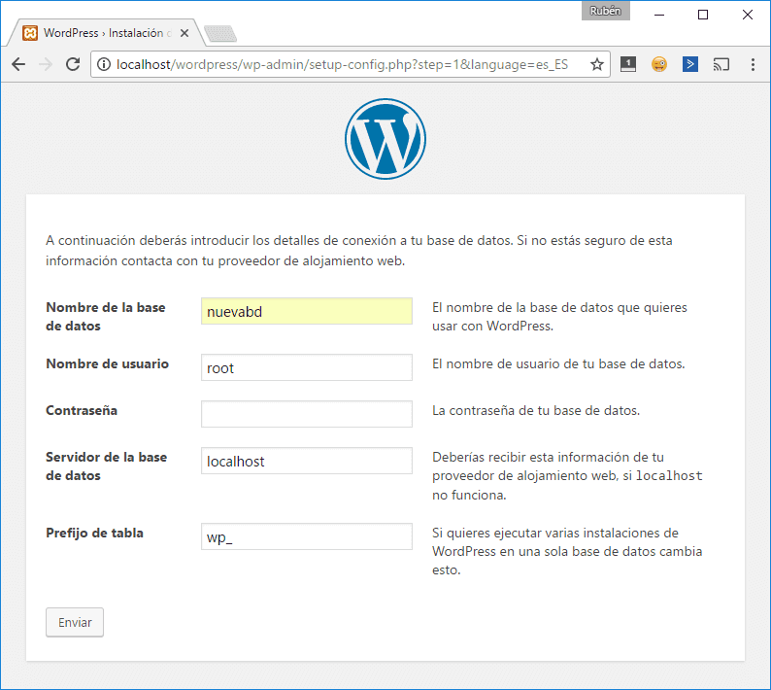

We can **access to our wordpress panel here**: http://localhost/wordpress/wp-admin/. We introduce our **user information and we are inside wordpress panel**. Now we are going to **install the chosen theme to our website**.

We can use free theme or payment themes, when we use free theme, **we must be careful because some themes have virus**. We download the chosen theme, **then we are going to install it**, there are two ways to install them:

– The recommended option is **using wordpress tools**, we go to the left menu and click in **appearance** and then click in theme. On the top we are going to click in upload button. **Once uploaded the theme, we activate it**.

– Another way is **using FTP program**, we copy our theme in this folder “wp-content/theme” **the next step is activate it**.

Install WordPress plugins

WordPress works with plugins, **they are smalls programs, they add functionalities**. To install plugins **we have two options**:

– We can **use wordpress panel**, this is the better way. We click “plugins”. Here we can see the installated plugins. **On the top click “add plugin”**. Here we can see the list of plugins that we can install. We **search the correct plugin and click install**, Finally, press the activate button.

[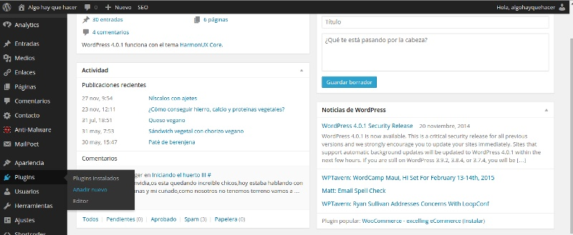](https://www.multiplicalia.com/wp-content/uploads/2018/01/como-instalar-plugin-wordpress.jpg)

– **Another way is to use FTP**. We search the plugin a download in our computer, **then we upload files using Filezilla**. We are going to **upload the file to te folder “wp-content/plugins”**. When upload finished, **we open wordpress panel in plugin’s page we activate it**.

Create and modify pages and posts[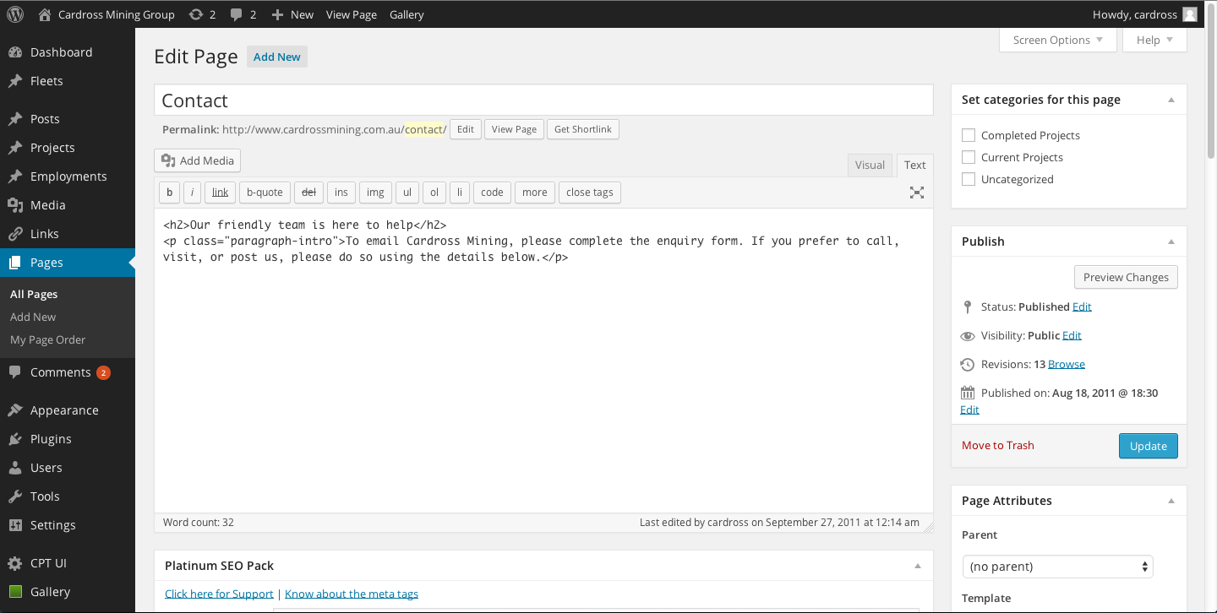](https://www.multiplicalia.com/wp-content/uploads/2018/01/wordpress-editor-pagina.png)

Now we are going to **create page and post for our website**. We click in “pages”, here we can **see the pages we have created**. We click **“add page” and open a new screen**. The first step is introduce Page’s title, **then we can introduce the page’s content**, we have 3 options:

– First option is to **use a visual compososer plugin.**

– Second option is to **use the visual wordpress screen.**

– The last option **is use HTML screen** , to use this option **we need HTML knowledge CSS strylesheet.**

The last step, on the right **we click the button “publish”.**

To create blog post **use the same options as in pages**, but within the post section. As in the page section **when accessing entries**, the list of created entries is displayed, and in the upper part of the screen **add entry**.

On the screen it comes out **the option to put the title of the entry and then the content block of the entry**, but in this case **we only have two options**:

– The first is the **visual part of wordpress**, which as I said in the previous section **works as Word or openoffice**.

– The second one is the **HTML option together with CSS**

Now click on the p**ublish button in the right margin of the screen**, to make it visible. In the margin of the right to publish we see more options for saving such as**save as draft if we do not want to publish the page** or entry we are creating.

Once created our pages and entries **we have to put in the menu of the web** so the user can navigate through the different pages.

**Conclusion:** We have installed XAMMP and wordpress.